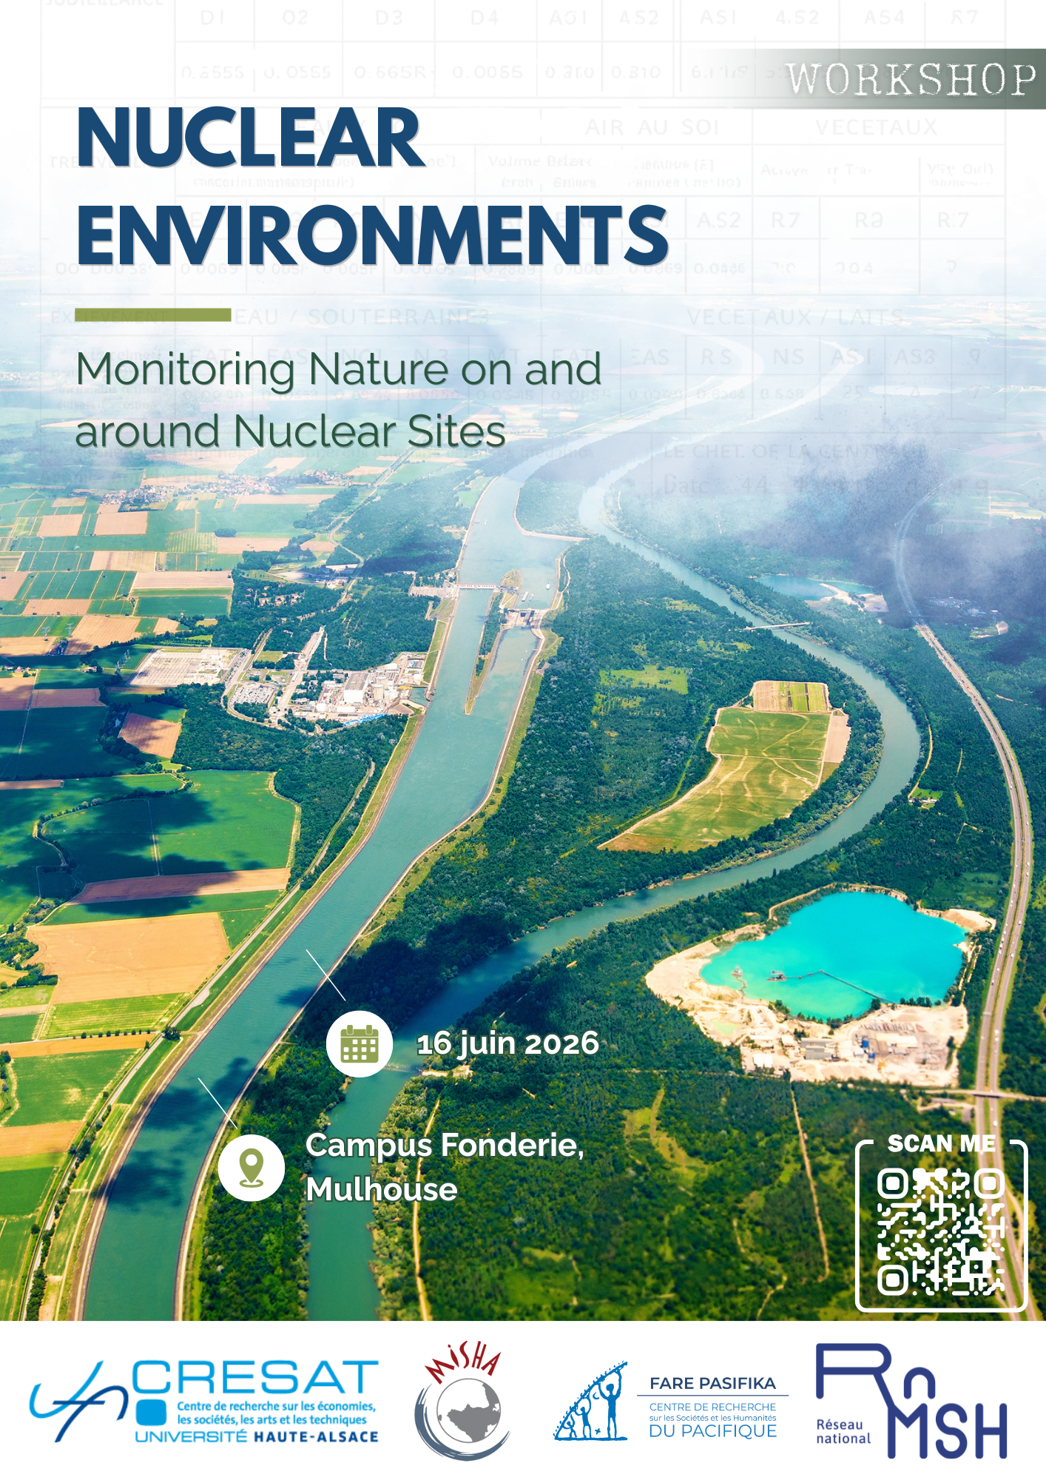

09:00 Coffee
09:15 Welcome Adress by Guido Braun, director of the CRESAT
09:25 A very very short introduction by Benjamin Furst
09:30 Manatea Taiarui (Université de la Polynésie française), Science, Diplomacy and Radioactive Fallout: International Monitoring of Water Radioactivity during French Atmospheric Nuclear Tests in the Pacific (1966–1974)
This presentation examines how French scientific experts, between 1966 and 1974, implemented rigorous monitoring of water radioactivity resulting from fallout of atmospheric nuclear tests conducted in French Polynesia. Led by the Direction des centres d’expérimentations nucléaires (DIRCEN) in close collaboration with the Quai d’Orsay (French Ministry of Foreign Affairs), this monitoring relied on tracking ocean currents, sampling campaigns, and the transnational movement of actors and practices across the Pacific. This study aims to trace the development of knowledge about water radioactivity and highlight the interconnections between scientific research and political, diplomatic, and military considerations.
10:00 Renaud Meltz (CNRS), The Aldebaran Ordeal: Politicians, Experts and Military Personnel Put to the Test by the First Explosion at the CEP
“The nuclear tests that France intends to carry out at the Pacific Test Centre began today with the detonation of an experimental plutonium fission device with a yield in the so-called tactical range. The explosion took place above Mururoa at 15:34 GMT, or 05:34 local time. The safety conditions laid down by government instructions were met at the time of the test and no incidents are to be reported.” Did the person drafting the official government statement on 2 July 1966 know that the Aldebaran cloud, launched from a barge skimming the lagoon’s surface, was currently drifting over the Gambier Islands, exposing the people of Mangareva to fallout whose levels exceeded within a few hours the 5 mSv threshold set as the maximum for a year?
We can now reconstruct the decision-making processes that led to this state lie, caught between the timing demands of politicians eager to equip France with a strike force as soon as possible and the local autonomy of the military and nuclear scientists who organised the tests under the watchful eye of the territory’s civil administrators. To do this, we must adopt a very detailed chronology, whilst taking into account the longer-term trajectories of the respective actors: the military (the director of the nuclear test centres, Jean Thiry, and the operational commander, Jean Lorain); the experts (doctors Jenri Jammet of the CEA and André Aeberhardt, head of the Joint Biological Monitoring Service, and his deputies on site, Pierre Le Guen and Philippe Million), but also, on the political side, Jacques Foccart and Pierre Billotte.
10:30 Discussion
- Coffee break -
11:00 Louis Fagon (Université de Lorraine), Monitoring, Modelling or Protecting the Environment around Nuclear Power Plants: the Case of the Rhône (1950s–1990s)
The nuclear industry, which has long been established on the banks of the Rhône, generates a vast amount of environmental data on the river. Water is indeed central to nuclear safety, but it is also the subject of scientific study, administrative oversight and, from the 1960s onwards, a fully-fledged water policy that has produced a wealth of expertise. Whether we are talking about nuclear industry stakeholders (the CEA and EDF) and their environmental departments, government bodies (the river basin agency, the navigation department) or activists (anti-nuclear campaigners and counter-expertise associations such as CRII-RAD), water is a central concern, yet not everyone is talking about the same river. Through an examination of environmental files and the debates surrounding water quality, the aim is to scrutinise the models and explore the construction of this ‘negotiated environment’ around power stations since the 1950s.”
11:30 Andrei Stsiapanau, Technoscientific Frontiers: Lithuanian Scientific Resistance and the Environmental Limits of the Ignalina NPP
This paper analyzes the friction between Soviet central planning and local scientific expertise regarding the Ignalina Nuclear Power Plant. Focusing on the 1980s controversy over Lake Drūkšiai's cooling limits, I examine how the Lithuanian Academy of Sciences used hydrological data and environmental monitoring to challenge Moscow’s extractive goals. I argue that these technoscientific processes were deeply political, serving as a primary site for asserting "sovereignty of the soil." By documenting the innovative, system-wide research program developed by local scientists, this study illustrates how ecological modeling and data exchange became essential instruments of institutional resistance against the Soviet nuclear frontier.
12:00 Cali Gur et Maéva Pécher-Linkcs: Surveillance on a Nuclear Power Plant on the Border: Fessenheim and the Rhine
This brief presentation of the initial findings of a collaborative research project focuses on environmental monitoring of the waters surrounding the Fessenheim power plant. It will highlight the diversity of responsibilities and stakeholders involved, illustrating a constantly evolving network of relationships, made even more complex by the site’s location on the border.
12:15 Discussion
- Lunch -
14:00 Per Hogselius, Atomic Shocks of the Old: Putting Water at the Centre of Nuclear Energy History
This article argues that the history of nuclear energy can and should be analyzed as a history of water. Taking inspiration from David Edgerton’s The Shock of the Old and recent efforts to merge the history of technology with environmental history, here the focus shifts from nuclear reactors to the “conventional” parts of nuclear power plants. This brings to the fore that a range of hydraulic technologies with long prehistories—pumps, pipes, valves, dams, dikes, and so on—have been crucially important for nuclear safety. The “atomic age” is fundamentally a hydraulic age and should be seen in relation to experiences gathered by past hydraulic civilizations.
14:30 Lucie Genay, Nuclear-Wildlife Partnerships at the Idaho National Laboratory
The site established in southeastern Idaho as the National Reactor Testing Station (NRTS) in 1949 is the cradle of the “green atom,” i.e., nuclear science being presented as a key technological solution to address an array of modern environmental woes, chief among them air pollution and climate disruption, and the creation of partnerships between nuclear sites and their natural setting to bolster the social acceptability of nuclear activities. The “greening” of Idaho’s nuclear installation was reflected in the site’s name change to the Idaho National Engineering and Environmental Laboratory (INEEL) in 1997, but links between nuclear and environmental research largely predate this post-Cold War reorientation. While the green atom is a multifaceted concept that involves a constellation of political and scientific debates and collaborations over time, this paper will focus specifically on the various ways in which scientists approached the Idahoan sagebrush ecosystem and its non-human inhabitants to pursue a wide range of objectives including conservationism, impact studies, experimentations in radioprotection, bioremediation, and PR communication. It addresses interactions between the site and its habitat, underscoring how landscape and wildlife have contributed to the development of what is now the Idaho National Laboratory (INL), as well as the relationship between Idahoans and their natural environment, notably how some have combined their support for nuclear power with environmental militancy. Exploring the ecosystemic services rendered to a nuclear installation and the rhetoric of pronuclear environmentalism that has sustained it enables to uncover some of the historical roots of influential movements today, notably ecomodernism, which gained prominence in the last twenty years.
15:00 Discussion
- Coffee break -
15:15 Olga Feldberg, The Limits of Containment: Risk, Memory, and Nuclear Governance in Semipalatinsk
From reactor design to Cold War doctrine, nuclear technology has always paid special attention to the idea of containment. This paper examines how containment logic extended into epistemic and mnemonic registers at the Semipalatinsk Nuclear Test Site in Kazakhstan. Drawing on archival research and ethnographic fieldwork, I argue that post-Soviet Kazakhstan used official commemoration and risk-based governance as mutually reinforcing instruments for bounding nuclear harm spatially, temporally, and epistemically. Different actors mobilize risk criteria and visions of the past and futures to make competing claims about who suffered and what should happen to contaminated space.
I separate them into three strategies for managing nuclear space: containment, expansion, and reduction through privatization. The paper then asks what reparative justice might look like when neither risk estimation or commemoration paradigms are equipped to address harm that is slow and ongoing, and entangled with the very tools used to measure it.
15:45 Benjamin Furst, A Strict Division of Roles: Environmental Monitoring of the French Nuclear Tests in the Pacific
The presentation introduces the environmental monitoring of nuclear French tests, designed to ensure their safety for human health, focusing on the surveillance of waters on the test sites and in French Polynesia, for which the expertise was often sought from experts outside the Pacific Experimentation Center. It will show that, due to this work between academic researchers and the military and engineers themselves, a very strict division of responsibilities led to two distinct tasks: academics were in charge of monitoring non-radioactive effects, while in the meantime serving as scientific counsel for technicians and medical staff who were evaluating the radioactive impacts of the detonations. This situation led to a one-way exchange where researchers contributed to military reports while being entirely shut off from any knowledge about radioactive consequences.
By questioning the means and policies surrounding this organisation, the presentation will show that while a thorough control over French Polynesia was enforced, some aspects of environemental and health surveillance escaped the vigilance of French authorities either for practical reasons or due to the human and non-human agencies at work.
16:15 Discussion
16:45 A very very short conclusion by Teva Meyer and Benjamin Furst
17:00 End of the workshop, drinks in Mulhouse

